COGNITIVE NEUROSCIENCE SOCIETY OF INDIA (CNSI)
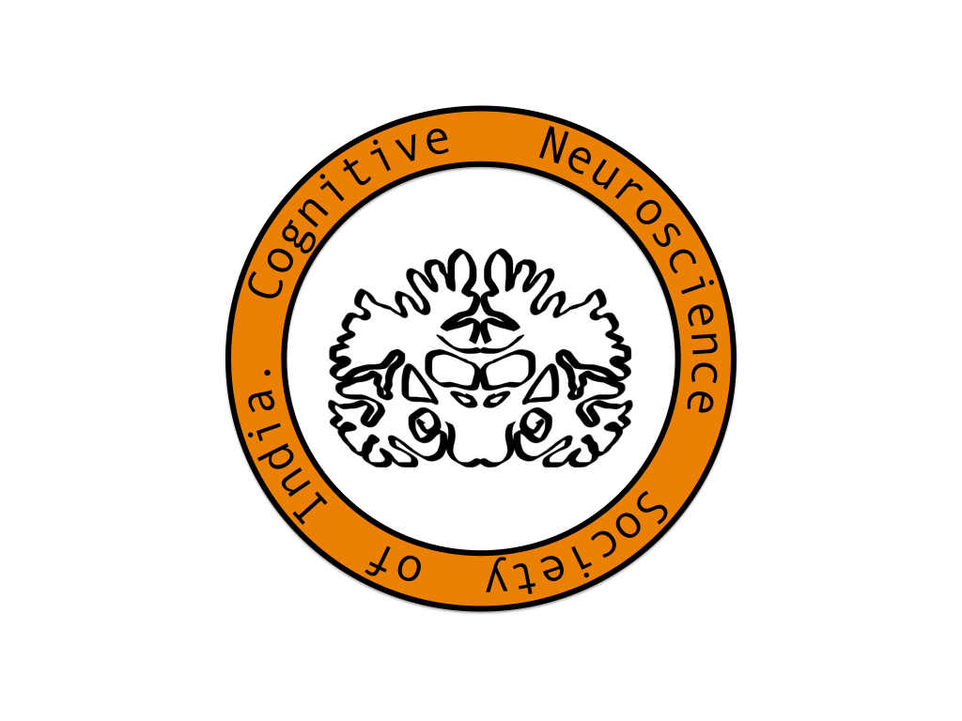
85-13, 4th Cross, Bhavani Layout, Christ School Road,
Bangalore – 560029
http://www.cnsi.org.in, contact@cnsi.org.in

REGISTERED IN 2015 AS PER SOCIETIES REGISTRATION ACT XXI OF 1960
JNR S474-2014-15/JNRS21

APPLICATION FORM FOR MEMBERSHIP

(PLEASE PRINT IN BLOCK LETTERS)

Application for Professional Membership ………………..
Associate Membership ………………..

Affix Photo

Name………………………………………………………………………………………………….…

Professional Affiliation/Designation…………………………….……………………………………………….

Official Address (Address for Correspondence)…….…………………………………………………………

……………………………………………………………………………………………………………

…………………………………………………………………………………………………………...

Email Id ……………………………………………………………………………………………………………

Telephone ……………………………… (Off) …………………………………(Mobile/O)

Past Appointments if any (Details)…………………………………………………………………...........................................
…………………………………………………………………………………………………………...
…………………………………………………………………………………………………………...
Alternate Postal Address..…………………………………………………………………………….

………………………………………………………………………………………………………………………....................
…………………………………………………………………………………………………………...…………....................
DEGREE/DIPLOMA…………………………………………………………………………………..…………..............

ANY OTHER SPECIFY ………………………………………………………………………………………………………………………………….

DESIGNATION: ……………………………………………………………………………………………………………….

NAME OF THE INSTITUTION: …………………………………………………………………………………..…………

PARTICULARS OF SPECIALIZATION IN COGNTIVE NEUROSCIENCE (Clinical/Research/Teaching/
Technology Development)

……………………………………………………………………………………………………………………………………………………………….

……………………………………………………………………………………………………………………………………………………………..

……………………………………………………………………………………………………………………………………………………………..

…………………………………………………………………………………………………………………………………………………………….

…………………………………………………………………………………………………………………………………………………………….

……………………………………………………………………………………………………………………………………………………………

……………………………………………………………………………………………………………………………………………………………

PUBLICATIONS (Attach Separate Sheets) ……………………………………………………………………..……………………………………………………….

Special (Core) Clinical/Research Interests …………………………………………………………………………….

………………………………………………………………………………………………………………………………

I am sending a sum of Rs …………………………………………………as Annual /Life Term Subscription

by Draft/Cheque No……………………….by Bank……………………………………..Dated……………………..

in favor of “Cognitive Neuroscience Society of India”, payable at Bangalore, (Add Rs-85
as Bank charges for outstation cheques).
- I certify that the particulars given above are correct.
- I am interested in the objectives of CNSI and hereby undertake to abide by the rules of the Society during the tenure of my membership.
- I have attached the copies of my professional certificates to substantiate my specialization in Cognitive Neuroscience

Any other Preferred Mailing Address…………………………..………………………………………………………

………………………………………………………………………………………………………………………..........

City……………………………… State…………………………….Pin Code…………………………………………

Signature of Applicant……………………………………………….……..……Date………………………………

Recommended by……………………………………………………Membership No…………………..…………

Signature…….…………………………………

Please send the application form to General Secretary, CNSI at the address given below-

Dr. John P. John
Additional Professor of Psychiatry
National Institute of Mental Health and Neurosciences (NIMHANS)
PB No. 2900, Dharmaram P.O., Hosur Road
Bangalore, India 560 029
Email: jpj@nimhans.ac.in

* Online Membership payment is coming soon

